- Introduction | 2
- Glossary | 3 - 4
- Standards of Practice Education  - Values Statement  - Practice Educator Professional Standards (PEPS) Domains | 4 - 5
- Practice Education Qualifications  - The Practice Education Curriculum  - Dudley’s Practice Educator Application Process  - Maintaining currency | 5 – 12
- Practice Educator Support Offer  - Funding and Workload Relief  - Honorarium Payments  - The Practice Educator Toolkit  - The Practice Educator Learning Programme | 12 - 13
- Social Work Student Practice Placement Guidance  - Student Placement Requests  - Pre-Placement Interviews  - Student Induction  - Practical arrangements (working hours, sickness / absence, travel, workload)  - Supervision  - Concerns  - Support for Students (training, support and resources).  - Post Social Work Qualification. | 13 – 20
Appendix 1 – The Values Statement | 21 - 22
Appendix 2 – The Practice Educator Professional Standards (PEPS) Domains | 23 - 27
Appendix 3 - Practice Educator Learning Programme | 28
Appendix 4 - Placement Interview Guidance | 29 – 30
Appendix 5 - New Starter’s Checklist | 31 - 34
- Introduction
A Message from Dudley’s Centre for Professional Practice

Practice Educators are key to improving standards in Social Work. They teach, supervise, and assess Social Work learners, developing their knowledge and skills, growing and nurturing the future generation of Social Workers. It is hence essential Practice Educators have the resources they need to deliver good quality practice learning experiences within the organisation.

Here in Dudley, Practice Education is an essential element of our Career Progression Pathway, and we encourage Social Workers to apply to become a Practice Educator if they have been practising for a minimum of two years. Whether this is to prepare for a career into management or to develop knowledge and skills further, Practice Education is a fantastic next step in your Social Work journey.

The purpose of this Handbook is to provide information and guidance around the arrangements in place to support and deliver Practice Education in Dudley. The Handbook been developed in line with the refreshed Practice Educator Professional Standards (PEPS) 2022, and provides guidance in relation to:

- Applying for and completing Practice Education qualifications;

- Teaching, supervising and assessing learners;

- The support arrangements in place for learners, Trainee Practice Educators, and Practice Educators.

- Glossary

Practice Educator Professional Standards (PEPS)
PEPS are the standards categorised into Domains those delivering Practice Education are expected to demonstrate.

Learner
Person undertaking the pre-qualification award (e.g. Social Work) or post-qualification learning e.g. ASYE, Best Interests Assessor (BIA), Approved Mental Health Practitioner (AMHP).

On-Site Supervisor
This person is responsible for the day-to-day support for the learner and will work closely with the Practice Educator in their overall assessment of that learner. They may be called ‘Work-Based Supervisors’.

Line Manager
Usually the person responsible for supervising and allocating workload to a qualified Social Worker.

Practice Educator
A registered Social Worker qualified to PEPS 2 who takes overall responsibility for assessing learners in Practice Education against relevant frameworks, including the Professional Capability Framework (PCF). They make the recommendation to the Practice Assessment Panel and the course examination board about the learner’s competence.

Trainee Practice Educator
The person undergoing training to be qualified to be a Practice Educator.

Practice Educator Mentor
A registered Social Worker qualified to PEPS 2 who will develop the skills and knowledge of the Trainee Practice Educator during the process of undertaking the PEPS. The mentor will not be making a final assessment in respect of the Trainee Practice Educator. Prior to taking on a mentor role, the Practice Educator should have had experience of supervising five learners, including students or newly qualified Social Workers they supervised during PEPS 1 and 2 training.

Practice Educator Assessor
A registered Social Worker qualified to PEPS 2 who will be responsible for assessing the Trainee Practice Educator against the Values Statements and PEPS Domains. Prior to taking on an Assessor role, the Practice Educator should have had experience of supervising five learners, including students or newly qualified Social Workers they supervised during PEPS 1 and 2 training.

- Standards of Practice Education

Values Statement
It is expected that those undertaking a role in practice education as a Trainee, Practice Educator Assessor, or Practice Educator Mentor demonstrate the Values Statement which have been adapted from ‘Values for Work-Based Assessors’ Social Work Reform Board (2010). The Values Statement closely reflect the BASW Code of Ethics (2021), including its position on Equality, Diversity and Inclusion and Anti-Racist Practice (BASW, 2021), and the domains of the Professional Capability Framework. Trainee Practice Educators will be required to demonstrate the Values Statement as part of the assessment process and in their ongoing role in Practice Education once qualified.

The Values Statement is attached to Appendix 1 of this document.

The Practice Educator Professional Standards (PEPS) Domains
The PEPS are split into four Domains. These Domains set out standards expected of those responsible for facilitating, supporting, and assessing the learning of Social Work practice, and ensuring their own professional development. The PEPS have been refreshed after consultation with a wide range of stakeholders and have been aligned to the Professional Capability Framework (BASW 2018) and Post Qualifying Standards in Social Work (DfE, 2018), and are mapped against the Values Statement.

The principles of the PEPS is to ensure those involved in the teaching, supervising and assessing of learners are experienced Social Workers against the Professional Capabilities Framework Level 7, with an interest in promoting Social Work education and committed to delivering this in a supportive, anti-oppressive manner.

Domain 1 | Domain 2 | Domain 3 | Domain 4
Working with others to organise an effective environment | Teaching, facilitating and supporting learning and professional development in practice. | Managing the fair and transparent assessment of students in practice. | Developing knowledge and continuing performance as a Practice Educator.

The PEPS full descriptors can be found in Appendix 2 of this document.

- Practice Education Qualifications

- All Practice Educators must be registered Social Workers.
- Practice Educators should be experienced and skilled Social Workers with at least two full years’ post qualifying experience at the start of the Practice Education training programme.
- All Practice Educators should be able to demonstrate that they are practicing at PCF Experienced Social Worker level in their practitioner role before enrolling on a Practice Educator course. This is to ensure that Practice Educators have the appropriate experience and capability to support and guide learners through complex casework, ensuring they are fully prepared for practice by the end of their final placement, and sufficiently experienced to meet the requirements of PCF at final placement.
- On-site supervisors of learners may be experienced or hold professional qualifications other than Social Work. If this is the case, there should also be a registered Practice Educator involved in the learner’s placement.
- Practice Education programmes may be delivered in one or two ‘stages’, but irrespective of mode of delivery, Practice Educators need to have had responsibility for supporting, supervising and assessing at least two learners, one of whom must be at pre-qualification level, before full qualification as a Practice Educator can be achieved.
- Practice Educators at both PEPS 1 and PEPS 2 should meet all Domain Statements in Section A, B, C and D by progressing through PEPS 1 and PEPS 2. The Practice Educator Trainee should be able to demonstrate an increased competency and reflection as they develop their skills and knowledge for each Domain.

Practice Education course providers normally deliver PEPS in two stages for the trainee Practice Educator to develop expertise, confidence, and experience in the role.

Stage 1: This is where the Trainee Practice Educator will have their first learner. Trainee Practice Educators at this stage will be able to supervise, teach and assess Social Work learners up to, but not being solely responsible for, the final placement prior to qualification. Stage 1 Trainee Practice Educators will need to have their assessment decisions overseen and confirmed/ endorsed by a PEPS 2 Practice Educator Assessor to ensure they are justified. Some Practice Educators may just undertake this element of the course and remain able to only support, teach and assess ‘first placement’ pre-qualification learners once this has been completed.

Stage 2: This is where the Trainee Practice Educator will have their second learner and be able to take responsibility as detailed below (Table 2). Trainee Practice Educators at this stage will be able to supervise and teach Social Work learners up to and including the last placement. These Trainee Practice Educators will have the authority to recommend, based on appropriate evidence, that learners are fit to practise at the point of qualification, but this decision still needs to be agreed with the Practice Educator Assessor and be ‘signed off’ by them.

The Table overleaf shows the stages a Practice Educator can independently assess pre-qualifying students.

Table 2 – Stages of Practice Education and Assessment of Learners
 | Stage 1 (studying) | After Stage 1 qualified | Stage 2 (studying) | After Stage 2 qualified
First Placement | Yes | Yes | Yes | Yes
Final Placement | Can undertake learner support and supervision but formal assessment documents such as the Mid-Point Review, Direct Observations and Final Report must be agreed and signed off by Practice Educator Assessor. | Can undertake learner support and supervision but formal assessment documents such as the Mid-Point Review, Direct Observations and Final Report must be agreed and signed off by Practice Educator Assessor | Can undertake learner support and supervision and sign off the Mid-Point Review and Direct Observations. The Final Report needs to be agreed and signed off by the Practice Educator Mentor / Assessor | Yes
Post Qualifying eg. ASYE, BIA, or AMHP | Can undertake learner support and supervision but formal assessment documents such as the Mid-Point Review, Direct Observations and Final Report must be agreed and signed off by Practice Educator Assessor. | Can undertake learner support and supervision but formal assessment documents such as the Mid-Point Review, Direct Observations and Final Report must be agreed and signed off by Practice Educator Assessor. | Can undertake learner support and supervision and sign off the Mid-point Review and Direct Observations. The Final Report needs to be agreed and signed off by the Practice Educator Mentor / Assessor | Yes

The Practice Education Curriculum

PEPS training courses will be taught and assessed at Post-Graduate Level. An indicative Practice Education Curriculum may include some or all of the following;
- Models and theories of supervision / how to be a reflective supervisor / building a learning relationship.
- Developing a learner’s capacity to be critically reflective / helping learners to understand and manage the emotional demand of social work and providing challenging and positive constructive feedback.
- Theories of adult learning and how these can be applied in the Practice Educator Trainee’s own practice and in work with learners to enhance reflection on development.
- The concept of the learning organisation and community of practice, and how these can be applied when working with the team and agency in the context of the contemporary framework of Social Work education.
- Research mindedness and developing the learner’s capacity to make good use of knowledge in practice. Developing the Practice Educator learner’s ability to use Practice Education research to inform practice and contribute to the knowledge base of Practice Education.
- Making fair and transparent assessments of learners. Working with learners who are struggling and whose practice is failing and enhancing the potential of all learners including high achievers.
- Understanding of, and critical engagement with, the experiences of people with lived experience of Social Work, including issues of culture and discrimination and social justice.
- Self-reflection and professional development / Practice Educators as leaders in the organisation / using own supervision/becoming a mentor.
- Knowledge of Social Work professional development frameworks for assessment and development.
- Expertise in reflective supervision and completing holistic assessments of the learner’s Social Work ability.

Assessment will always include direct observation of the Practice Educator Trainee. To be fully qualified as a Practice Educator 2, the Practice Educator Trainee has to have been observed on at least three occasions during the course. Two of these observations must be of supervising a Social Work Student, and the third can be undertaken by a peer, i.e. Practice Educator colleague observing another activity and can include peer reviewed supervision, leading a group supervision, or leading a teaching and development opportunity for a student.

Dudley’s Practice Educator Application Process

The flowchart below sets out the Practice Educator application process in Dudley. Please note, all applicants should have discussed applications with their Line Managers as part of their Annual Review and Supervision.
Dudley’s Centre for Professional Practice (CPP) formally advertise the Practice Educator Programme, setting out the number of spaces available.

The Social Worker completes the Application Form, sending this to CPP by the submission date. Where the number of applications exceed the number of spaces, priority will be given to those applicants who submitted their applications first.

The CPP Lead checks the essential criteria is met, including commitment to the programme, and manager’s approval.

Yes
No

The CPP Lead will present a list of names to the CPP Team Manager, Service Manager, and Principal Social Worker.
The CPP Lead will advise applicants of the outcome of their applications, and if appropriate, discuss other learning and development opportunities. Applications will be prioritised for the following cohort.
The CPP Lead will advise the applicant of the outcome, and support them to access alternate learning and development opportunities to help them meet the criteria in the future.

Maintaining Currency

If a Practice Educator has not had a learner for two years, their Practice Education qualification can be considered lapsed. However, a Practice Educator can maintain currency through other Practice Education activities, such as;
- Organising and supporting placements.
- Providing teaching and learning opportunities e.g., supporting Apprentices.
- Observing other experienced Practice Educators.
- Contribution to the writing of assessments and reports for a learner (overseen by a qualified and current Practice Educator).
- Supporting the assessment and learning of Newly Qualified Social Workers (overseen by a qualified and current Practice Educator)
- Using these experiences of Practice Education as evidence to support ongoing registration as a Social Worker with the regulator.
- Engaging with BASW training sessions for Practice Educators through the Training / CPD section of the website.
- Undertaking the Practice Educator Mentoring role for a Trainee Practice Educator.

The volume of activity will reflect the amount of time out of practice and upskilling required to meet the requirements of the role.

Those Practice Educators whose qualifications are considered lapsed may be able to refresh their qualification in a number of ways, including:
- Submission of a short portfolio, evidencing how they have kept currency in line with the Values Statement and PEPS Domains.
- Presenting practice learning examples to a quality assurance panel.
- Accessing a Refresher course.
- Involvement in decisions undertaken by local / regional practice assessment boards or panels.
- Other methods agreed in consultation with the learning provider and placement provider.
CPP will keep track of Practice Educator currency via the Practice Educator database, and will maintain contact with all Practice Educators to explore potential involvement in Practice Education for the new academic year, and alert Practice Educators if their qualification is about to lapse. CPP will provide advice and support with activities to help Practice Educators regain their currency.

- The Practice Educator Support Offer
Funding and Workload relief
In Dudley, Social Workers receive a fully funded opportunity to gain their Practice Educator qualification. They can express their interest by contacting Dudley’s Centre for Professional Practice at CPP@dudley.gov.uk.
It is recommended that the Trainee Practice Educator’s workload be adjusted by 20% during the period they are supervising a student. This is to ensure the Practice Educator Trainee can adequately manage and oversee the learner’s workload, and provide the required supervision, support and assessment. This should be agreed with the Line Manager in advance of the learner starting their placement.
Practice Educator Trainees supervising a learner are also entitled to one day’s protected time per placement to allow time to complete the assessment reports. The scheduling of this will need to be agreed with the Line Manager.
Honorarium Payments
Once a Social Worker gains their Practice Education Stage 1 / 2 qualification, and has gone on to support a learner through their first placement (70 days), they will receive a payment of £700 upon completion of the placement. If the placement is not completed as a result of the learner leaving the course due to ill health or other unexpected circumstance, a pro-rated amount of fee will be paid.
Once a Social Worker gains their Practice Education Stage 1 / 2 qualification and has gone on to support a learner through their final placement (100 days), they will receive a payment of £1000 upon completion of the placement. If the placement is not completed as a result of the learner leaving the course due to ill health or other unexpected circumstance, a pro-rated amount of fee will be paid.
The Practice Educator Toolkit
Dudley’s Centre for Professional Practice (CPP) will provide each Trainee Practice Educator with a Practice Educator Toolkit, containing relevant resources to aid their development as Practice Educators. The Toolkits will contain useful resources to aid reflective supervision and critical reflection, support learners with linking theory to practice, and support the fair and transparent assessment of practice and development of learners.
The Practice Educator Learning Programme
In Dudley, those undertaking a role in Practice Education are invited to attend the Practice Educator Learning Programme, delivered by Dudley’s Centre for Professional Practice, as well as regional events. The Learning Programme will focus on the domains of the PEPS and will be held as far as possible to coincide with placement start, midpoint and end dates, which vary through the academic year and between different learning providers. The workshops will take place in October, January, April and July of each academic year. There will also be an opportunity for those undertaking a role in Practice Education to attend one-to-one sessions with Dudley’s Centre for Professional Practice as required to discuss their development, any support requirements, and potential future student placements to continue their Practice Educator qualification.
There is a library of Practice Education resources held within Dudley’s Centre for Professional Practice that can be accessed as and when required.
- Social Work Student Practice Placement Guidance

Student Placement Requests
All requests for student placements will be made through Dudley’s Centre for Professional Practice (CPP), and will be explored by the CPP Team Manager, who will log details of the request and explore potential placements with the Student Lead. If a Manager, Social Worker or other member of staff within the organisation is contacted regarding a student placement, they should discuss this with the CPP Team Manager in the first instance to ensure the correct process is followed.

Should the student have previous convictions/cautions, their situations will be considered on a case-by-case basis so as to not preclude the offer of a placement. The CPP Team Manager will discuss any potential placements with the Principal Social Worker for a final decision to be made around whether the placement should go ahead. The process aims to ensure that no student is discriminated against in line with the Equality Act 2010, and all students applying for a placement will be considered, as long as the correct process has been followed.

The CPP Team Manager has oversight of the student profiles sent, in order to match students to appropriate teams and Practice Educators, depending on capacity at the time of the request. Once the decision is made to proceed to offering the student an interview, the student profile will be emailed to the allocated Practice Educator who will read the profile, and together with the CPP Team Manager and Student Lead, make contact with the student within 10 working days to arrange a placement interview.

Pre-Placement Interviews
All students confirmed for interview should be offered a Pre-Placement Interview which should take place no later than 15 working days prior to the placement start date, and much earlier where possible.

The guidance in Appendix 4 provides information on key areas to discuss and cover with the student during the interview. Students must also bring a copy of their DBS check, their previous Placement Report (if being interviewed for a final placement), their Learning Support Statement (if relevant), as well as their driving license and vehicle insurance documents. Please note students need to hold Business Class 1 insurance for Social Work placements, and must demonstrate that this cover is in place prior to the placement start date.

In the event concerns are raised in the Placement Interview about any aspect of the student’s presentation or suitability, then this should be discussed with the CPP Team Manager and Student Lead, prior to any agreement for the student to start a placement. Reasons for a student being unsuccessful at interview may relate to their presentation, attitude, organisational skills, preparedness for the interview, and timekeeping.

If the student has been successful in securing the placement, they should be notified of this no later than 2 working days after the interview. Once the placement has been confirmed, the CPP Team Manager / Student Lead will send the relevant Placement Handbook directly to the Practice Educator, and if relevant, the Placement Supervisor.

In the event that no concerns have been raised in the interview, the Practice Educator should agree a start date with the student in line with their learning provider timescales. The first day will be on a Monday, which is the day Dudley Children’s Services Induction takes place. Inductions take place at the main Social Work building - Corbyn Road, Dudley.

Once the placement has been confirmed, CPP will complete the Student Temporary Payroll Set- Up Form and forward this to HR. Once the student has been set up, CPP will complete the New Starters Checklist. This includes arranging for the student to obtain their identity badge, ordering and providing a work laptop and mobile phone, and requesting log-in details for work extension numbers and ICT.

All equipment should be returned to the Practice Educator on the last day of the student’s placement. Under no circumstances should students be using their personal mobile phones for work purposes.

Student Induction
It is the responsibility of the Practice Educator to ensure the student completes the Dudley Children’s Services Induction. For further information around the Induction, please access the following link: https://www.dudleycpp.org.uk/inductionpack

During the Induction, students will spend time shadowing and observing colleagues and gaining an understanding of key policies and procedures. Students will also be required to spend time visiting different services across Children’s to understand the journey of the child and the types of practice undertaken in each service.

Services include:
Family Centres within Family Solutions;
Families Come First;
The Front Door;
Duty and Assessment;
Safeguarding and Support;
Children in Care and Care Leavers;
Children with Disabilities;
Safeguarding and Review (Independent Reviewing Officers and the Local Authority Designated Officer).

Practical Arrangements
Student Working Hours
Students undertaking practice placements with Dudley should comply with the contractual attendance and hours of duties of Monday to Friday, 9am to 5pm. These will be confirmed in the Practice Learning Agreement within the portfolio, and as per the Social Work programme requirements. It is recognised there will be times duties may require flexibility in the working hours due to the nature of the role. In this situation, the Practice Educator will need to ensure that the student takes back the extra hours worked as per the flexible working policy. However, students should not build up time and take whole days out of the placement.

Sickness/Absence
Students are required to complete the placement attendance requirements in full. Should the student be unwell or absent from work at any time, they are required to contact the office and notify the Practice Educator of the absence on the first and last day of sickness. If the student is unable to attend due to sickness for more than one week, then they must provide a GP fit note to the Practice Educator and Practice Tutor, confirming they are well enough to return, and identifying any additional support requirements for the student if necessary. If the student is an internal candidate, i.e. a Social Work Apprentice, any annual leave to be taken during the programme should be agreed by the Practice Educator in advance. In all cases, any missed days must be clearly recorded and made up at the end of the placement unless otherwise agreed by the learning provider.

Travel
Students are required to travel to and from placement and make appropriate arrangements for any travel during the working day to meet with service users or partner agencies as needed.

Car users will need to ensure that they hold Business Class 1 car insurance. It is the student’s responsibility to check their policy and make any changes needed prior to the placement start date. Dudley will not provide any financial contribution to any required payments.

Students who do not drive will need to ensure they make alternative arrangements for transport to carry out duties required of them within their case work.

Any travel expenses occurred during working hours can be claimed back through the Practice Educators and team they are placed in. The specific service in which the student is placed will be responsible for reimbursing the student’s travel costs. Receipts and necessary evidence of expenses should be provided with the claim. Students cannot claim back for travel expenses incurred during their journey to and from placement and home.

Students are required to complete the mileage log form, and the Practice Educator and Line Manager will need to sign off and agree the mileage log. All receipts and/or parking tickets will need to be attached to the completed form. The student will need to give the approved log to their Finance Team (Senior Business Support Team) who will process the application via a supplier payment request.

Workload
It is the responsibility of the Practice Educator, together with their Line Manager, to manage casework the Student Social Worker is supporting. This casework should take into consideration the student’s ability and previous experience. It is recommended the student supports casework involving eight children during a first placement, and up to twelve children during a final placement. This can be increased dependent upon capability and previous experience of individual students, but needs formal discussion and agreement between all parties involved.

Children’s cases cannot be allocated to students in their own right. All of the children’s cases the student Social Worker is supporting will need to be recorded as being co-worked by the student, and need to have a named, qualified Social Worker allocated.

Should any conflict of interest arise, such as the student knowing a family personally, the student must notify the Practice Educator immediately so appropriate decisions can be made.

Supervision
For first placements, Practice Educators will be required to provide weekly supervision to their student throughout the placement, to include oversight of casework, reflective practice, and development. Any discussions about children’s cases should be recorded directly onto the child’s file by the Practice Educator in line with the Supervision Policy.

For final placements, at the student’s Midpoint Review, a discussion can be held as to whether supervision can be reduced to fortnightly for the second half of the placement. Where there is a Practice Educator qualified to Stage 1 and an off-site Practice Educator qualified to Stage 2, supervision will be undertaken alternately between the two.

Concerns
Where there are concerns about a student’s practice and there is a potential the student will fail the placement, the Practice Educator and student should inform the Practice Tutor at the relevant Learning Provider, and the Student Lead / CPP Team Manager at the earliest opportunity, and a Placement Concerns Meeting should be convened in line with the programme policy. The Practice Educator should be prepared to provide written evidence of the concerns in preparation of the meeting.

The meeting will be convened with the Practice Tutor, Student, Practice Educator, and CPP Team Manager / Student Lead. It is possible that during this meeting, a recommendation will be made to end the placement. This may be due to a number of reasons, such as breach of Dudley’s policies, or concerns around risk to families, or the ability of the student to demonstrate the required professional capability. The Practice Educator should ensure that responses to concerns are appropriate and liaise with the CPP Team Manager / Student Lead to formulate steps of support.

At times, there may be disagreements or disputes between a Practice Educator and student. Any disagreements should be addressed by raising the issues with the other party, and this should be recorded and dated by all parties as they occur. In most cases, the issues will be resolved over the course of the placement. If the issue cannot be resolved directly, then the CPP Team Manager should be notified, as well as the learning provider, so that a plan to address the dispute can be agreed.

Any concerns relating to the practice of the Practice Educator will be explored jointly with the Line Manager and Student Lead / CPP Team Manager, and appropriate steps taken as necessary in line with Dudley’s policies and procedures.

Support for Students
Training
Dudley has a comprehensive offer of training. Students are able to attend this training by booking on through the CPP website - https://www.dudleycpp.org.uk/eventsandtraining.

Students will also have the opportunity to attend Taught Days with newly qualified social workers undertaking Dudley’s Assessed and Supported Year in Employment (ASYE) programme. The Student Lead / CPP Team Manager will make contact with students to inform them of these opportunities as and when they become available.

Students will also be able to access support and guidance from their Line Manager and colleagues within the team, as well as the CPP team.

Resources and Tools
The CPP website has a Practice Resources folder. Here there are key documents and links that can be used in the completion of portfolio work and research. There is also a link to the West Midlands Social Work Teaching Partnership repository of useful Practice Education documents, presentations and other useful materials.

Students can register with Research in Practice while on placement with Dudley, and have access to a range of relevant resources to inform and underpin their practice. Students should visit the home page and register using their Dudley email address.

Post Social Work Qualification
If a student has successfully completed their first placement, they will be invited to join the CPP mailing list for future training opportunities, and contacted when adverts for the ASYE Programme opens for their qualifying year. If a student successfully completes their final placement, arrangements will be made to support the student to complete an application for a newly qualified Social Worker post, so they can potentially join Dudley as an employee and complete the ASYE programme.

The availability of newly qualified Social Worker posts will be subject to the needs of services and vacancies at the time of the student’s placement completion.

Appendix 1
Values Statement
In order to promote anti-oppressive and anti-discriminatory practices, Practice Educators and Supervisors will:
- Ensure that consideration is given to the needs and interests of people with lived experience of Social Work when assessing the capability and skills of students at all stages of the assessment process.
- Manage professional / personal boundaries, their use of authority and power within the assessment relationship and recognise and act upon the implications for their assessment of practice.
- Update themselves on best practice in assessment and research on adult learning and apply this knowledge in promoting the rights and choices of students and managing the assessment process.
- Advise students and other learners of their rights and actively challenge oppression and discrimination which may be experienced by the student or other learners.
- Identify and question their own values and prejudices and respect and value the uniqueness and diversity of students and other learners.
- Accept and respect student’s and other learner’s circumstances and understand how these impact on the learning and assessment process. Practice Educators and supervisors should recognise and build on the strengths of students and learners, and consider their individual learning styles with a range of assessment methods (including those preferred by the student).
- Assess in a manner that does not stigmatise or disadvantage individuals and ensures equality of opportunity. Show applied knowledge and understanding of the significance of lived experience, poverty, racism, ill health, disability, gender, social class and sexual orientation in managing the assessment process and recognise and work to prevent and counter unjustifiable discrimination and disadvantage in all aspects of the assessment process.
- Take responsibility for the quality of their work and ensure that it is monitored and appraised; critically reflect on their own practice and identify development needs in order to improve their own performance, raise standards, and contribute to the learning and development of others.

Appendix 2
PEPS Domain Descriptors and Mapping 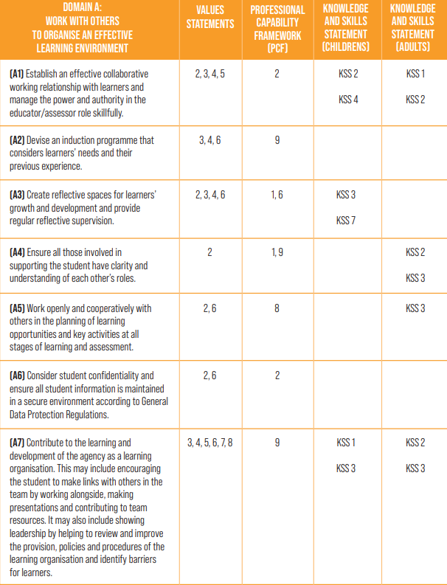

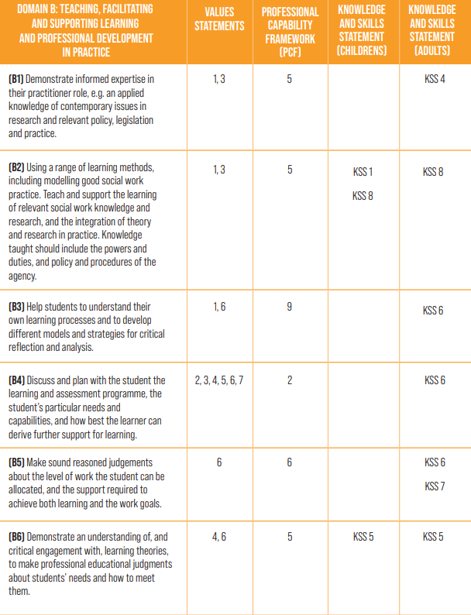
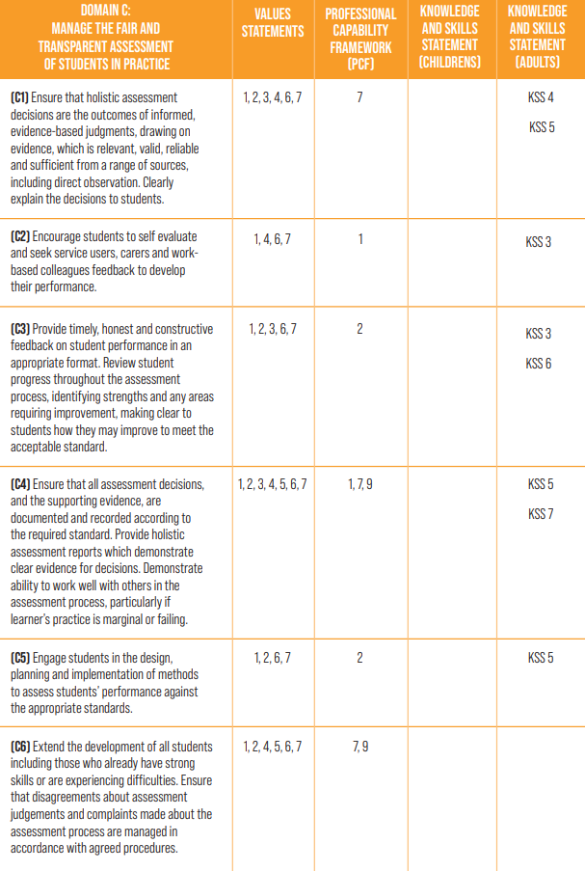
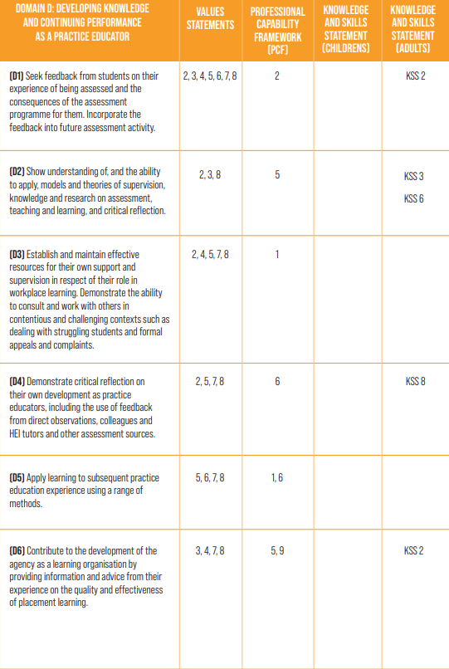
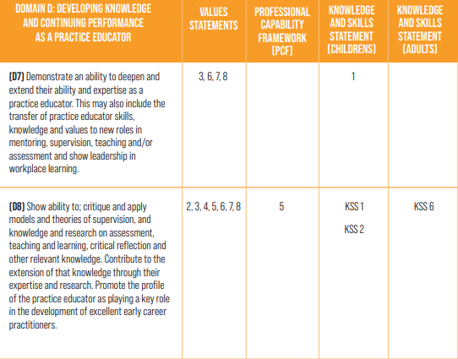

Appendix 3
The Practice Educator Learning Programme 2023 - 2024
18/01/2023 | Session 1 – An Introduction to Practice Education. This will include an overview of the Practice Education Offer in Dudley, going through the updated Practice Educator Handbook and Toolkit.
19/04/2023 | Session 2 – Managing and Supporting Challenging Student Placements. This will include details about the support available to Practice Educators, managing challenging placements and students, the procedures in place to facilitate this process, and Support and Action Plans.
19/08/2023 | Session 3 – Practice Educator Professional Standards (PEPS) and Direct Observations - (aligning these with the Professional Capabilities Framework and Social Work Post Qualifying Standards). This session will provide an overview of the refreshed PEPS (July 2022) and offer support and guidance for observing students whilst on placement, and the ways in which their feedback can be evidenced against the PCF and PQs.
22/11/2023 | Session 4 – Planning Inductions, Preparing for Mid-Point and Final Placement Meetings, and Top Tips for Report Writing. This session will offer practical tips for arranging Induction for student placements and Newly Qualified Social Workers (ASYE), guidance for Practice Educators preparing for Placement Meetings, and tips in report writing for Mid-Point and Final Meetings.
NB: All sessions will allow time for Practice Educators to discuss their placements thus far, how they are finding them, if there are any practice/placement issues and will leave time for questions and answers.
Appendix 4
Pre-Placement Interview Guidance
The purpose of the Pre-Placement Interview is for the student and Practice Educator and / or the Practice Supervisor to meet to decide whether the student will be suitable to work in their service and on placement with them, and to discuss their learning needs and how they can be met.
Students should treat the interview in the same way they would a job interview, and make sure they prepare thoroughly beforehand. All students should be on time (unless unforeseeable circumstances arise), be appropriately dressed, and have prepared.
Once the Practice Educator receives the Student Profile and is in agreement with the potential placement, together with the Student Lead / CPP Team Manager, they should make contact with the student and offer dates for an interview. The interview will take place prior to the Placement Agreement Meeting.
Students will need to show their DBS check at the Placement Interview. Practice Educators will need to check the dates and ensure they cover the length of placement.
Students who are on final placement should provide the Practice Educator with an electronic copy of their Final Report from their first placement.
Potential Interview questions:
- Can you tell us about any previous experience you have that you think will be relevant to the work you will undertake on this placement?
- Tell us about some of your modules at University and how you will utilise the knowledge on this placement.
- Can you tell us some of the qualities and attributes you think are important for a Social Worker?
- What is it you would like to get out of a potential placement in Dudley?
- What are your learning needs for this placement?
- Can you talk to us about any areas of interest you have in practice?
- Do you have any disabilities, health needs or extra learning needs that you need any support with while on placement?
- Are there any questions that you want to want to ask or any further information that you would like?

Appendix 5
Dudley Children’s Services: New Starters Checklist

The New Starter Checklist is now in place to ensure all new starters have everything they need to begin their role, and they are well inducted and supported from the beginning of their journey with Dudley Children’s Services.

Employee Information
New Starter Name:  Start Date: | Team Manager:  Team and Service Area:
Cost Centre:

Actions prior to the new starter beginning
Requesting a Payroll Number | Completion Date
- Permanent member of staff: Team Manager to request the Payroll Number from Human Resources (HR) via email; HR.Transactions@dudley.gov.uk
( Ext 1300)

- Agency member of staff: Team Manager to complete the Dummy Payroll Form and send to HR via email; HR.Transactions@dudley.gov.uk
- Students: Team Manager to complete the Student Dummy Payroll Form and send to HR via email;
HR.Transactions@dudley.gov.uk
Actions after Payroll Number received – New Starter Form (ID Badge / Equipment / Access to Buildings) | Completion Date
- Team Manager to complete a New Starter Form here and request the ID Badge and laptop/equipment if required.
- A My ICT call reference number will be received.
- Team Manager to request access into buildings via email; ProSoftAdmin.CS@dudley.gov.uk.

Actions after Payroll Number and Dudley E-mail Address Received (Liquid Logic Training and Liquid Logic Account, CPP Training Programme, CPP Induction) | Completion Date
Liquid Logic Children’s System – LCS Training
In order for the new starter to access LCS, Team Managers need to email the Dudley’s Centre for Professional Practice (CPP) inbox at CPP@dudley.gov.uk with the new starter’s full name, job title, team, the name of their Line Manager, their e-mail address, and their payroll number.
After providing these details, CPP will create the new starter’s Liquid Logic (LCS) e-learning account and contact them via email with instructions. They will also support the new starter with setting up their PHEW Training account, enabling them to book on to Dudley’s Training Programme and the CPP Induction.
Once the new starter has completed their LCS e-learning, the Team Manager should request a new Liquid Logic Account using this form: http://wdsv:8080/assystnet/application.jsp#serviceOfferings/643
(If there is already an active request with ICT, the Team Manager can send them an update to say the e-learning has been completed).

Individual Induction Plan | Completion Date
The Team Manager will need to develop and implement an individual Induction Plan for the new starter, consisting of a range of learning experiences, such as shadowing opportunities, buddying, mentoring, guided reading, attending core training etc. | To be in place by the new employee’s first day.

Actions after the new starter has begun
Meet and Greet | Completion Date
On their first day, the new starter is to be greeted at their office base by their Team Manager. They are to be shown around the building, ensuring their ID Badge grants them access. The new starter can be introduced to their team, Service Manager, and Head of Service (when available).

Building and Workspace Orientation, Key Discussions | Completion Date
The new starter is to be shown the location of staff facilities (toilets, lockers etc); and key discussions should be held around the new starter’s individual Induction Plan, core policies, processes and procedures, and health and safety, including the council’s approach to work and the fire procedure (fire alarm tests, fire safety meeting points).

Induction | Completion Date
The new starter will receive an email from the Learning and Organisation Development Team, inviting them to the Corporate Induction. This is a mandatory Induction, and a good opportunity to share essential information about working for the local government and Dudley Metropolitan Council. Connect - Corporate Induction  The new starter will also need to attend the Directorate Induction, delivered by CPP. They can book on to the Induction via the CPP Website: https://cpp.event-booking.org.uk/events-list  The Team Manager will need to implement the Individual Induction Plan for the new starter. | Within 8 weeks of start date  Within 2 weeks of start date
Training, Policies and Procedures | Completion Date
The new starter should be encouraged to review the policies, procedures, and practice guidance on the CPP website, and book on to Dudley’s Core Training Programme for Children’s Practitioners and Managers: https://www.dudleycpp.org.uk/
E-Learning and Policies | Completion Date
All new starters need to complete the Council’s mandatory training and policies.
An email will be sent to the new starter with a link to access the Council’s mandatory training and policies, but they can also be accessed here: https://dudleymbc.insight4grc.com/UserHome/Learning/Default.aspx

