Contents

Introduction | Page 3
KSS 1 – Promote and Govern Excellent Practice | Page 4
KSS 2 – Developing Excellent Practitioners | Page 6
KSS 3 – Shaping and Influencing the Practice System | Page 9
KSS 4 – Effective Use of Power and Authority | Page 11
KSS 5 – Confident Analysis and Decision-Making | Page 12
KSS 6 – Purposeful and Effective Social Work | Page 15
KSS 7 – Emotionally Intelligent Practice Supervision | Page 17
KSS 8 – Performance Management and Improvement | Page 18

Introduction
Who is this Handbook for?
Dudley’s Centre for Professional Practice created this Handbook as a supportive learning tool for Child and Family Practice Supervisors, to increase their knowledge and understanding of the Social Work Post Qualifying Standards (aka Knowledge and Skills Statement). The Knowledge and Skills Statement provides the basis for accrediting Practice Supervisors in Child and Family Social Work Practice, whose primary function is to supervise the practice and decision-making of Child and Family Practitioners, and to develop the skills of individuals and teams within Child and Family Social Work Services.

What will this Handbook Cover?
This Handbook will provide an overview of the Knowledge and Skills Statement, including some useful tools and models to use in practice, and factors to consider when working with Child and Family practitioners.

What are the Knowledge and Skills?
- Promote and govern excellent practice
- Developing excellent practitioners
- Shaping and influencing the practice system
- Effective use of power and authority
- Confident analysis and decision-making
- Purposeful and effective social work
- Emotionally intelligent practice supervision
- Performance management and improvement

KSS 1 – Promote and Govern Excellent Practice

This KSS suggests that in order to encourage and promote good practice in their teams or workforce, supervisors should:
- Be recognised for having extensive knowledge and skill in Social Work
- Shape, influence, set high standards and motivate others
- Lead by example, showing integrity, creativity and resilience
- Be visible and accessible to staff
- Design and implement measures to assure quality practice and throughput of work
- Challenge decisions and ensure they are underpinned by evidence and theory
- Monitor the well-being of children in care, ensuring they are happy and have ambitions for their futures

What are the Qualities of a Good Leader?
‘A leader is one who knows the way, goes the way and shows the way’.
(The Open University, 2013)
There is evidence that managers’ characteristics such as leadership style, support, consideration and empowerment strongly influence the wellbeing and performance of their staff and impact on absenteeism and retention. (Community Care, 2015)
Supervisor’s Tip
It is useful for Practice Supervisors to reflect on their Leadership Style, taking into account their strengths and the impact their style has on practitioners, children, and families, as well as considering if there are areas for further development, i.e. encouraging reflective practice or time management.

How does Being a ‘Good Leader’ Benefit Staff?

- Staff feel able to approach their supervisor for case discussions, informal supervision, to discuss learning, development and training opportunities and at times, discuss personal or family issues that may/be impacting on their practice.
- Staff feel happier and well supported at work, therefore potentially reducing absenteeism due to sickness or stress.
- Practitioners are able to practice in a positive, reflective and restorative environment and this may increase the quality of their practice with children and families.
- Supervision offered to staff is of a higher quality.

KSS 2 – Developing Excellent Practitioners

KSS 2 states that Practice Supervisors should:
- Recognise and value the expertise of practitioners.
- Explain and champion a practice framework and set an expectation for this to be used in practice.
- Understand different patterns of family functioning and pair it with the service response most likely to effect change.
- Recognise the strengths and development needs of practitioners, using observation, reflection and feedback (including from children and families).
- Acknowledge that there are different learning styles and decide when is best to teach or draw on the practitioner’s own knowledge.
- Invest available resources into staff and service development.

What are Learning Styles?
Practice Supervisors need to know and understand not only their own, but Practitioners’ styles of learning. This enables a Supervisor to support and challenge practitioners to develop into increasingly effective child and family workers.
Practice Supervisors can utilise several tools to help assess their own and others learning styles and to support the learning and development of practitioners. It is useful to consider that practitioners will benefit from adapting more than one learning style, and that not all scenarios in practice will allow for the practitioner to use the style they are familiar with.
How can I find out the Preferred Learning Styles for my Team Members?
There are many different tools for assessing the learning style of individuals, each with their own pros and cons. One tool that supervisors can utilise in support of learning styles assessment is the Honey and Mumford Learning Styles Questionnaire. This theory proposes that there are four learning styles which individuals typically associate with:
Activists – Those who learn by doing and enjoy role plays, brainstorming and problem solving
Theorists – Those who like to understand the theory behind practice, and enjoy using models, theories and finding out background information
Pragmatists – Those who like to try new ideas in practice and enjoy being shown new techniques and imitating good practice
Reflectors – Those who learn by observation and thinking and enjoy learning from feedback and coaching

It is also useful to consider the Four Learning Styles in this way:
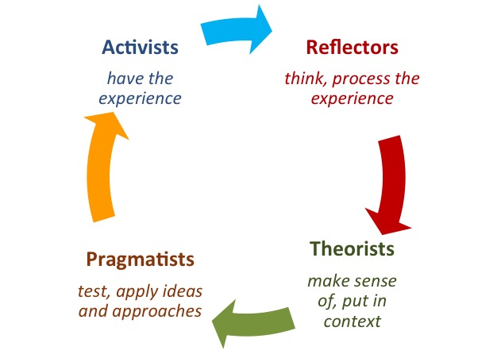

The Honey and Mumford Learning Styles Questionnaire can be located here:
https://www.open.edu/openlearn/ocw/pluginfile.php/629607/mod_resource/content/1/t175_4_3.pdf

Kolbs Learning Style Inventory
Another tool to use to assess the learning style of your team members is Kolb’s Learning Style Inventory.
This theory encourages individuals to complete a Learning Style Inventory that asks them to answer several questions.
The individual then has to score their responses and plot the number on a ‘Learning Style Profile’ Chart so they can visually see which learning style they associate with the most.

Four Learning Style Outcomes
Abstract Conceptualisation
This learner places an emphasis on doing, with a focus on influencing and changing situations.
Active Experimentation
This learner focusses on the meaning behind ideas/situations and like to reflect and understand.
Reflective Observation
This learner enjoys being part of experiences, are empathetic and like the use of theories.
Concrete Experience

This learner relies on logic and ideas and are more scientific in their approaches

To undertake the Learning Style Inventory for yourself or a team member, please follow the link below:
http://www.bunbury.wa.gov.au/pdf/environment/u472/Appendix%2019%20U472%20Community%20Facilitator%20Kolb%20Questionnaire%20Final.pdf

KSS 3 – Shaping and Influencing the Practice System

The KSS state that a supervisor should:
- Provide a safe and calm environment for staff.
- Create an ethos where staff are motivated and ambitious.
- Use resources to the best effect.
- Encourage constant reflective thinking.
- Build and develop influential and respectful partnerships between practitioners and partner agencies.
- Pay attention to different structures and pressures which can shape the thinking of others.
- Share practice knowledge and influence the wider organisation and national systems.
- Offer constructive advice and creative, strengths-based solution to difficulties.

Encouraging Reflective Thinking
Practice Supervisors should not only be reflective thinkers themselves, but should be encouraging and embedding this practice amongst other practitioners. Reflective Thinking is a skill that children and family practitioners and supervisors can continue to develop throughout their careers. It encourages individuals to keep the child in mind and to reflect and think about their own skills and approaches to their work.
Using reflective thinking in practice allows practitioners and supervisors to feel ‘safe’ in their work environment where they can talk about their experiences. A safe atmosphere at work will encourage practitioners to share their practice knowledge, be knowledgeable and be motivated.
Supervisors would benefit from incorporating reflective questions in supervision/informal discussions such as:
- How do you feel that this went?
- What do you feel went well/not well?
- Was there anything that surprised you?
- What would you do differently in the future?

Gibbs Reflective Cycle

Supervisors can use a variety of tools in practice to encourage themselves and practitioners to become more reflective. Gibb’s Reflective Cycle is one theory that can be used in practice and in supervision as a way of encouraging reflective thinking
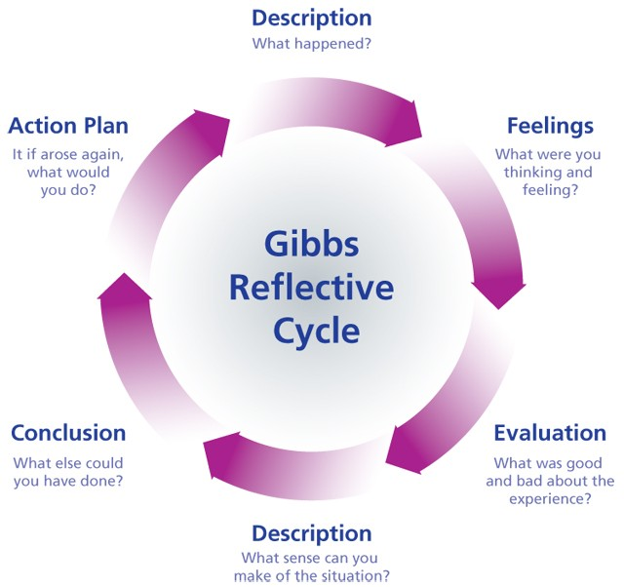

KSS 4 –

Effective Use of Power and Authority
The KSS state that a supervisor should:
- Use an ethical approach to the exercise of authority.
- Maximise opportunities for children and families to make informed choices.
- Possess an up to date knowledge of legislation and case law.
- Exercise statutory powers, ensuring that actions are proportionate to risk.
- Encourage practitioners to be clear, honest and respectful when explaining plans to families.
- Recognise the patterns of relationships between professionals and identify where these can compromise family welfare and safety of children.
- Invite challenge and debate.
- Consider diversity, discrimination and the impact of poverty.

Using the Restorative Approach with Practitioners
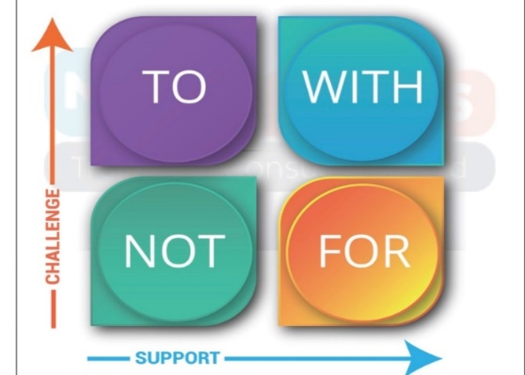
- The Restorative Approach is a key element of Dudley’s ambition to become an authority that puts children and their families at the centre of what we do.
- Restorative practice is a values-based relational way of being, that is needs-led and strengths-focussed. It embodies a set of core beliefs, principles and behaviours that promote a way of being with people that actively and explicitly promotes change by working WITH people on a high challenge, high support basis.
- Practice Supervisors should strive to demonstrate and embed the Restorative Approach in their management style.
- This approach should encourage Practice Supervisors to work WITH their staff; encouraging high quality work and achieving best outcomes for children and families, whilst also challenging their staff and supporting them to develop.

For practical ways of using this approach in practice, please see the Restorative Practice Handbook found here: https://www.dudleycpp.org.uk/restorative-practice

KSS 5 – Confident Analysis and Decision Making

The Case Management Process
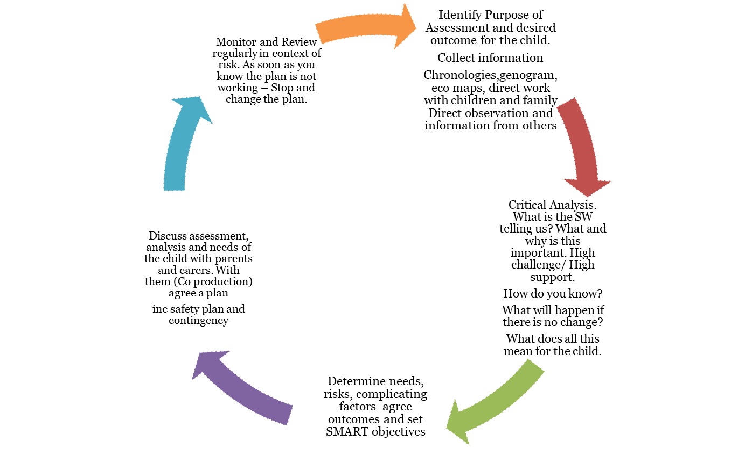

Assessment is a Process
Analysis and reflection should be happening at every stage of the assessment process.
Key points are:
- Aims –Why, what will be achieved, seriousness for the child if needs not met, clear outcomes and work to achieve these.
- Context - family history- what we know, open minded approach, understanding emotional implications, information is directly relevant.
- Expertise - to be clear about concerns demonstrate hypotheses.
- Style - logical, succinct, jargon free.
- Evidence - underpinning theoretical knowledge, explicit evidence, informed prediction of outcomes for the child if needs are unmet, confident analysis, owning what you write.
- Views - provide a clear understanding of the child’s life and how this stage has been reached, view of child and their family and analysis of these.

Hypothesising…

- Look at the broader picture...
- What we’re there for might not be the only thing we need to know about.
- Remember, the initial Hypothesis is incomplete...we are missing information...don't stick to one judgement.
- Its about disproving or proving a hypothesis and moving between these:
Professional Curiosity
Child’s Voice and Journey

5 Anchor Principles
What is the assessment for? – Purpose – identify key issues. Research, practice experience, observation of the family.

What is the story? – Identify relevant facts, circumstances and connected events which form a coherent narrative.

What does the story mean? - Getting the meaning out of the facts is key to effective analysis. Show your workings, hypothesising, testing, reflecting, planning.

What needs to happen? – Here is the problem, what is the solution? What does the story tell us about the needs?

How will we know we are making progress? – What do we want to achieve for this child? Have we achieved our planned outcome? If not, why not?

Things we need to help Social Workers avoid:

Links to Further Learning and Resources
Analysis and Critical Thinking in Assessment: Resource Pack –
https://www.rip.org.uk/resources/publications/practice-tools-and-guides/analysis-and-critical-thinking-in-assessment-resource-pack-20132014/
Tips for Improving Analysis and Decision Making in Social Work Video –
https://www.youtube.com/watch?v=jqa-XkpyI1A
Analysis and Critical Thinking in Assessment
https://www.local.gov.uk/sites/default/files/documents/analysis-and-critical-thi-0c9.pdf
Halo Bias Video - https://www.youtube.com/watch?v=T_SN4FouFn8
Negativity Bias Video - https://www.youtube.com/watch?v=E09077HRurg
Stereotype Bias Video - https://www.youtube.com/watch?v=7FgqGAXvLB8
Confirmation Bias Video - https://www.youtube.com/watch?v=jOjIAiJCNIk
Attribution Bias Video - https://www.youtube.com/watch?v=1jBAetCVYwc

KSS 6 – Purposeful and Effective Social Work

Managing Risk in Social Work – Tips for Practice Supervisors
- Managing risk is at the heart of social work – give social workers freedom to practice positively and effectively while holding them to defensible decisions and challenging poor practice.
- Supervise, don’t micro-manage.
- Learn from Serious Case Reviews.
- Be aware of factors that can hamper risk management – e.g. burnout or compassion fatigue can lead social workers to minimise risk of harm.
- You can’t do everything – if high caseloads are impacting on effective risk management this must be conveyed to senior managers.

Dimensions of Supervision

Reflective Supervision

SMART Plans in Case Management
Effective questions to ask Social Workers: -
- What are we worried about?
- What do we want for the child for us to be satisfied that we do not need to be involved?
- What is the detailed plan - who is doing what, when, how, by when and with whom - how will we know we have succeeded?
- When are we going to check the plan is working?
- What is our safety plan and our contingency?

Links to Further Learning and Resources
Tips on Managing Risk in Social Work - https://www.communitycare.co.uk/2017/01/13/tips-managing-risk-social-work/
Reflective Supervision: Resource Pack - https://www.rip.org.uk/resources/publications/practice-tools-and-guides/reflective-supervision-resource-pack-2017/
What is SMART Planning?
https://www.proceduresonline.com/dudley/childcare/user_controlled_lcms_area/uploaded_files/SMART%20Planning%20Guidance.pdf
Managing Practice Guide
https://www.scie.org.uk/publications/guides/guide01/
What Makes a Good Manager?
https://www.communitycare.co.uk/2009/09/11/what-makes-a-good-manager/
Effective Supervision in Social Work and Social Care
https://www.basw.co.uk/system/files/resources/basw_40205-2_0.pdf
How do you Manage the Reflective Supervision Juggling Act?
https://www.communitycare.co.uk/2017/09/05/manage-reflective-supervision-juggling-act/
Effective Supervision in a Variety of Settings
https://www.scie.org.uk/publications/guides/guide50/

KSS 7 – Emotionally Intelligent Practice Supervision

Emotional Intelligence
- Emotional resilience is the ability to manage environmental difficulties, demands and high pressure. It is having the ability to withstand these challenges and emerge stronger and more resourceful (Walsh, 2008).
- Cole et al. (2006) found that supervisors who actively explored emotions within supervision produced positive emotions in their workers, which in turn raised performance.
- Key attributes required of a supervisor to deliver supervision (Morrison, 2005): -
  - Self-awareness: being confident in your own abilities but knowing where you might need support
  - Self-regulation: being professional, keeping calm under pressure
  - Motivation: wanting to improve, not just get through
  - Empathy: being aware of the feelings of others as individuals or as a group
  - Social skills: being a good communicator

Links to Further Learning and Resources
Developing Emotional Intelligence Video
https://www.youtube.com/watch?v=n9h8fG1DKhA
Supporting Emotional Resilience within Social Workers: Practice Tool https://www.rip.org.uk/resources/publications/practice-tools-and-guides/supporting-emotional-resilience-within-social-workers-practice-tool-2014-
Emotions, Social Work Practice and Supervision: An Uneasy Alliance? https://www.tandfonline.com/doi/full/10.1080/02650533.2012.745842
Emotional Intelligence, Emotion and Social Work: Context, Characteristics, Complications and Contribution https://academic.oup.com/bjsw/article/37/2/245/1705334
Surviving or Thriving? Enhancing the Emotional Resilience of Social Workers in their Organisational Settings https://www.research.ed.ac.uk/portal/files/64319339/Palattiyil_JSW_2018_SurvivingOrThriving.pdf
How to Supervise your Peers
https://www.communitycare.co.uk/2011/08/30/how-to-supervise-your-peers/

KSS 8 – Performance Management and Improvement

Karpan’s Drama Triangle
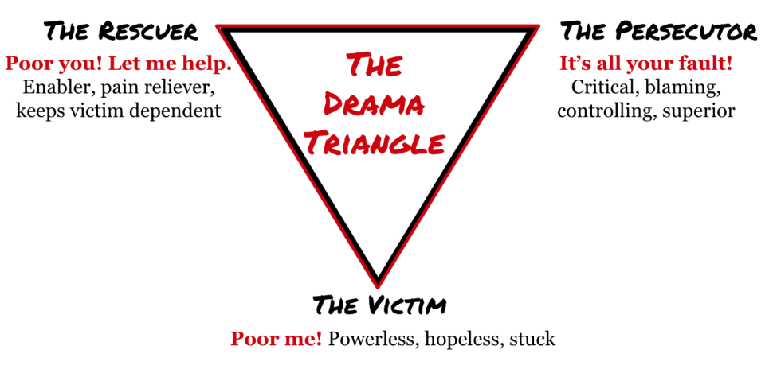

- The Victim - treated as or accepts role of victim but will abdicate responsibility for the situation and blame others for the position.
- The Persecutor – coerces or persecutes the person in the victim position. Acts in own interests, wants to scapegoat and punish victim for situation/failure to meet expectations. Denies responsibility for the situation.
- The Rescuer - intervenes to ‘help the Victim’ as sees as powerless to take over and save them from the persecutor. Blames the persecutor but does not empower the victim or hold boundaries.

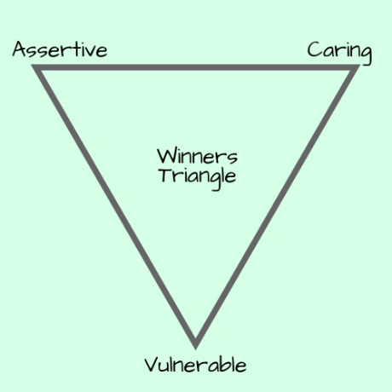
Winners Triangle

- The Persecutor becomes The Assertive position – acting in own interests but taking responsibility for what they want and asking for this rather than punishing others for not getting it.
- The Rescuer becomes The Caring position – remains in touch with own needs but aware that the other person is responsible for themselves. Maintains appropriate boundaries and empowers rather than disempowers.
- The Victim becomes The Vulnerable position - this can still be unpleasant but the vulnerable person accepts responsibility for themselves and becomes aware of their needs. This can be empowering as acknowledging the reality means they are no longer a victim who can be manipulated by the rescuer or persecutor.
Styles of Resolving Conflict (Thomas and Kilman 2007)

- Competing - When competing you pursue your own concerns at another person’s expense, using whatever power appropriate to win. Competing may mean standing up for your rights, defending a position you believe is correct, or simply trying to win.
- Collaborating - When collaborating you work with another person to find solutions to both of your concerns. It involves exploring issues together and learning from each other’s insights to deliver fair outcomes.
- Compromising - When compromising you find a quick and mutually agreeable solution. It may require splitting the difference or reaching a fast middle-ground position to a situation.
- Avoiding - When avoiding you don’t immediately pursue the concerns/conflict. Avoiding may result in diplomatically sidestepping an issue, waiting to address an issue until a better time, or removing yourself from a threatening situation.
- Accommodating – When accommodating you neglect your own concerns to satisfy those of another. Accommodating may lead to selfless generosity or charity, obeying another person’s orders when you don’t want to, or yielding to another’s point of view.

Motivation – Hygiene Theory; Herzberg (1960’s)
Herzberg's findings revealed that certain characteristics of a job are consistently related to job satisfaction, while different factors are associated with job dissatisfaction. These are:
- Factors for Satisfaction
  - Achievement
  - Recognition
  - The work itself
  - Responsibility
  - Advancement
  - Growth

- Fixing the causes of dissatisfaction won’t create satisfaction. Nor will adding the factors of job satisfaction eliminate job dissatisfaction.

- Factors for Dissatisfaction
  - Company policies
  - Supervision
  - Relationship with supervisor and peers
  - Work conditions
  - Salary
  - Status
  - Security

CORBS Feedback Model for Performance Management
Principles of CORBS feedback model:
- Clear statement – give clear and concise information.
- Owned by the person speaking – your own perception, not the ultimate truth. How it made you feel. Use terms such as “I find” or “I felt” and not “You are”.
- Regular – give immediately or as close to the event as possible. NEVER delay
- Balanced – balance negative and positive feedback. DO NOT overload with negative feedback.
- Specific – base your feedback on observable behaviour. Behaviours that the recipient can change.

Links to Further Learning and Resources
The Drama Triangle Video
https://www.youtube.com/watch?v=E_XSeUYa0-8
Herzberg’s Motivators and Hygiene Factors
https://www.mindtools.com/pages/article/herzberg-motivators-hygiene-factors.htm
COBS or CORBS Feedback Model for Performance Management
https://rapidbi.com/cobs-or-corbs-feedback-model-for-performance-management/
Professional Standards – Social Work England https://www.socialworkengland.org.uk/standards/professional-standards/
Research in Practice KSS Supervisor Resources https://www.rip.org.uk/search/?search_area=site&keyword=kss-supervisors-management&topic=43&type=&searchSubmit=SEARCH
Dudley Council Policies and Procedures
https://www.dudleycpp.org.uk/policies-procedures
Dudley Council Practice Standards
https://www.dudleycpp.org.uk/practice-standards
How to Prepare for a Difficult Conversation Video
https://www.youtube.com/watch?v=Pbgq-SINr0w
Managing Work – Caseload Management - https://www.scie.org.uk/publications/guides/guide01/managing-work/caseload.asp

